# Lab 3 - SQL Injection with Burp Suite

## Tasks

## 1. Retrieving hidden data

* Before you execute the injection on the proxy (i.e., click on **Forward**), take a screenshot of the content of the injection that is displayed on the proxy. (Please do your own work!)



* Take a screenshot of the outcome like below. (Please do your own work!)

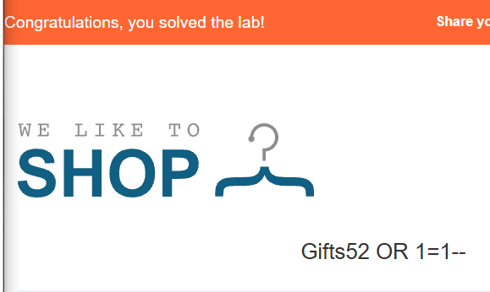

## 2. Blind SQL injection

* Before you execute the injection on the proxy (i.e., click on **Forward**), take a screenshot of the content of the injection that is displayed on the proxy. The following does not have an injection yet.



* Take a screenshot of the outcome like below.

